**Step 1: Create a free stule project and enter you private repository link in Git section with its ceredential like Username and password as token.**

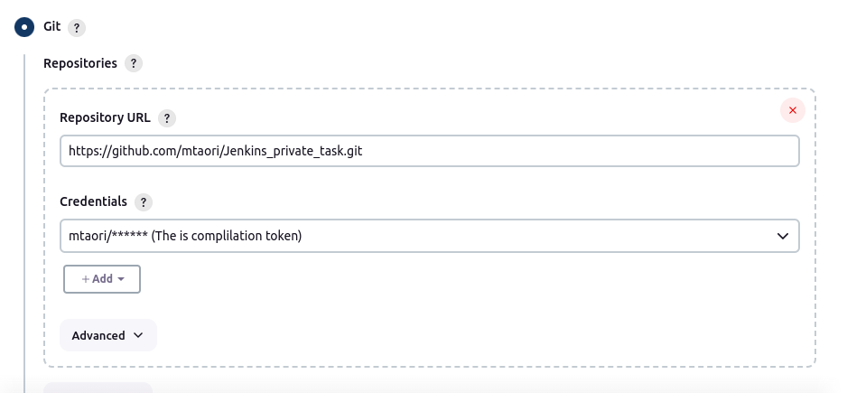

**Step 2: Add the branch name:**

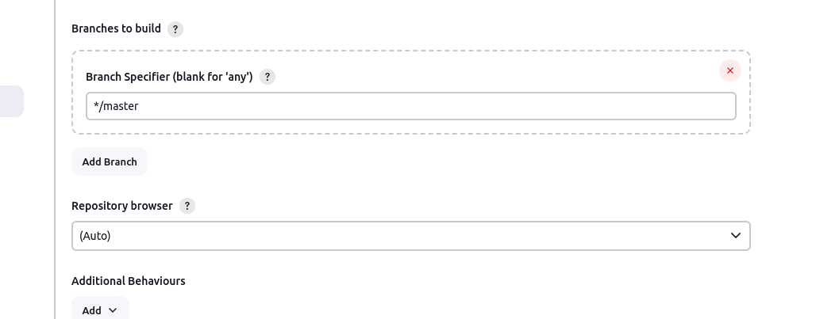

**Step 3: Add the maven version and set goals to test, then save and apply:**

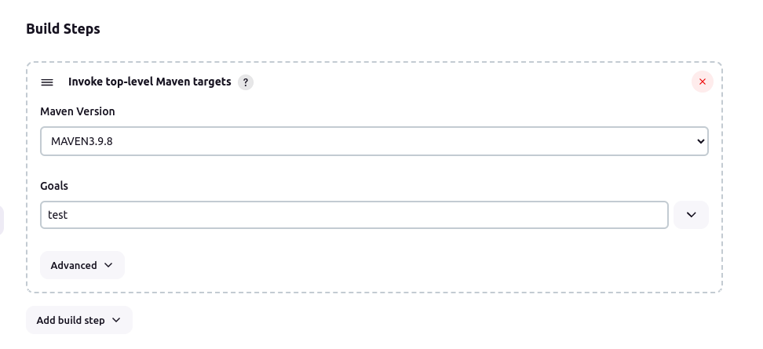

**Step 4: see the output in console output tab:**  
  
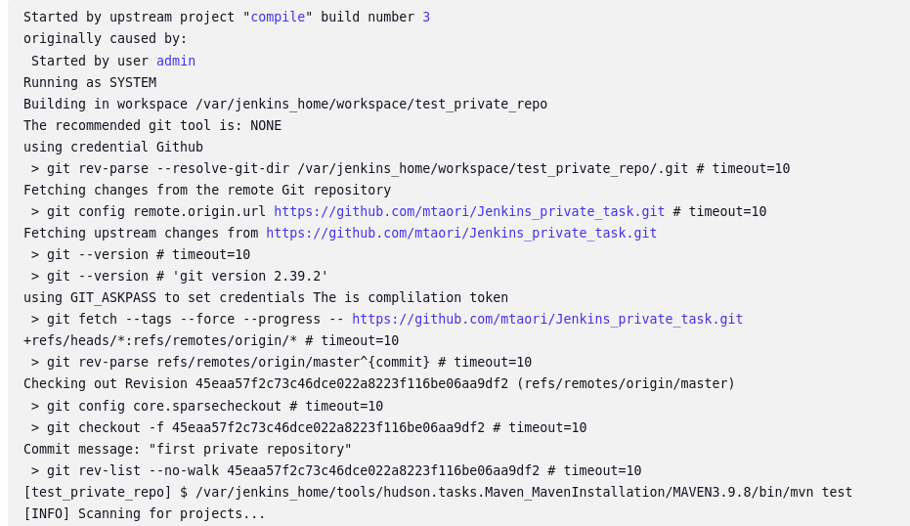

If it shown SUCCESS in console output at end then it build correctly